Pracovný list - Podnebné pásma ÁZIE 1
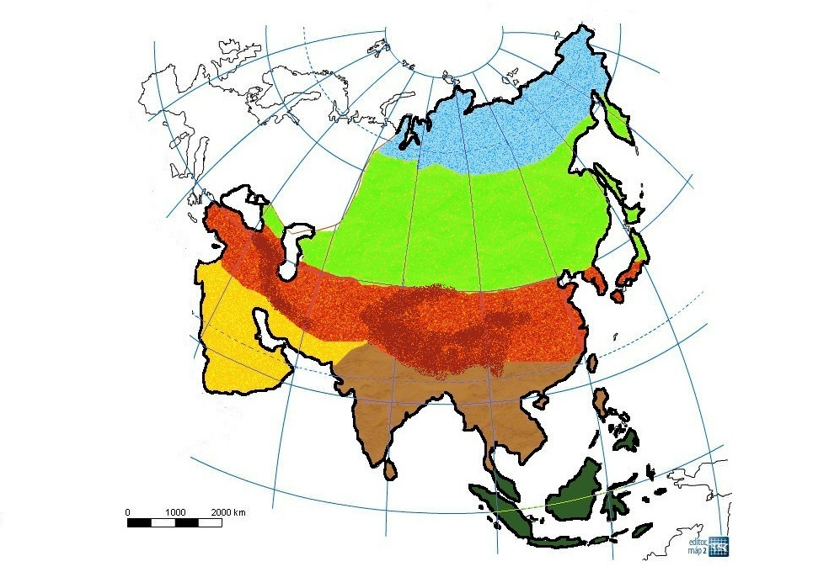

1
2

4 3
5

6

Doplňte legendu k mape.
1 ..............................................................
2 ..............................................................
3 ..............................................................
4 ..............................................................
5 ..............................................................
6 ..............................................................

Pracovný list - Podnebné pásma ÁZIE 1

1
2

4 3
5

6

Doplňte legendu k mape.
1 ..............................................................
2 ..............................................................
3 ..............................................................
4 ..............................................................
5 ..............................................................
6 ..............................................................

